**Preparation and Maintenance of ZOHO Books for TravelTrax Tours**

**Project Team members : Sowmiya.M, Sharihathul Farhana.J , Sumithra Devi.K, Tharani.R**

**1. INTRODUCTION**

**1.1 Overview:**

This project is deal with TravelTrax Tours, a tour operator, leverages Zoho Books to manage their bookings, track expenses, and handle invoicing for their customers. They can generate professional invoices, reconcile payments, and monitor their financial performance. Zoho Books helps them streamline their financial operations and enhance customer service.

**1.2 Purpose:**

By maintenance of accounts in ZOHO Books, We have created the Items, Vendors creation, Preparation of Purchase Order, Purchase Invoice, Customer creation, Preparation of Sales order, Sales Invoice, creation of bank account, creation of new accounts, recording journal entries, recording expenses, recording bank receipts and payments and viewing of financial reports like Profit & Loss account, Balance sheet, GST Reports, Journal report, Account receivable summary report, Account payable summary report, etc.,

**2. Problem Definition & Design Thinking**

2.1 Empathy Map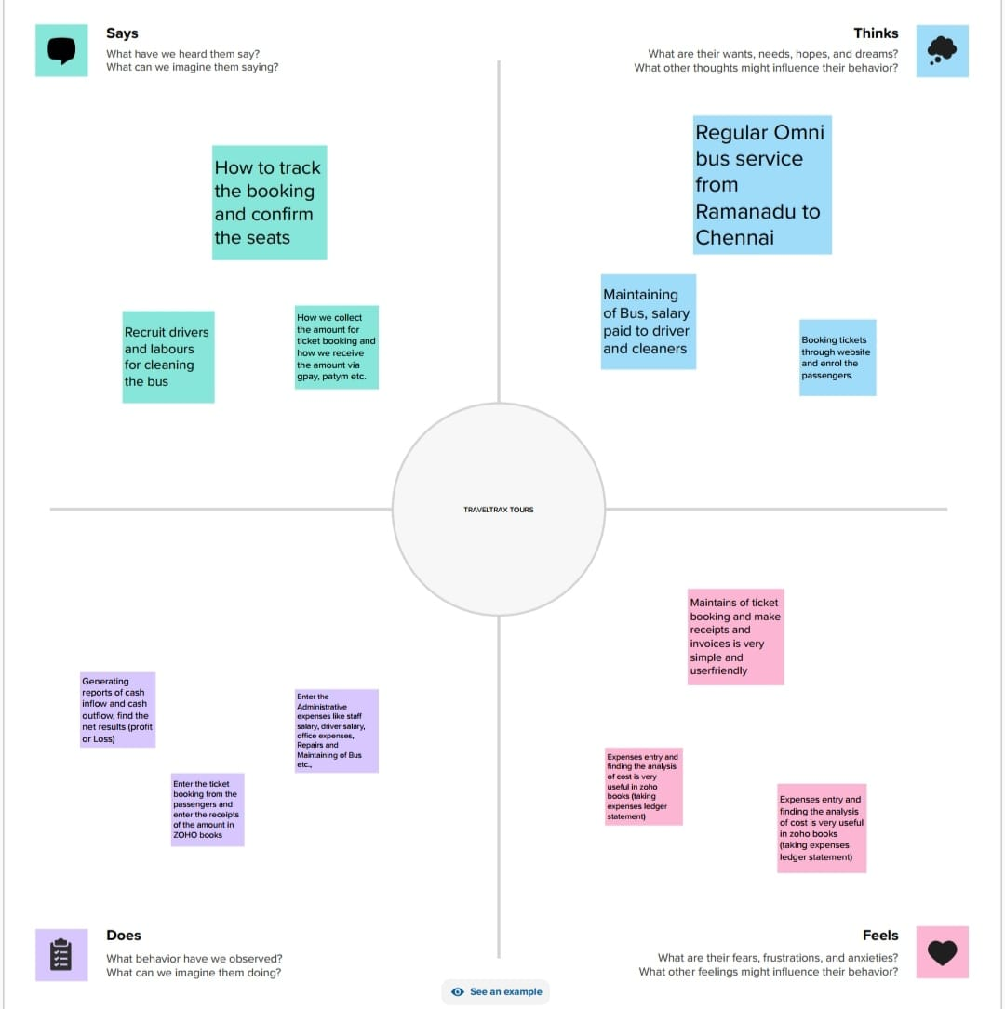

2.2 Ideation & Brainstorming Map

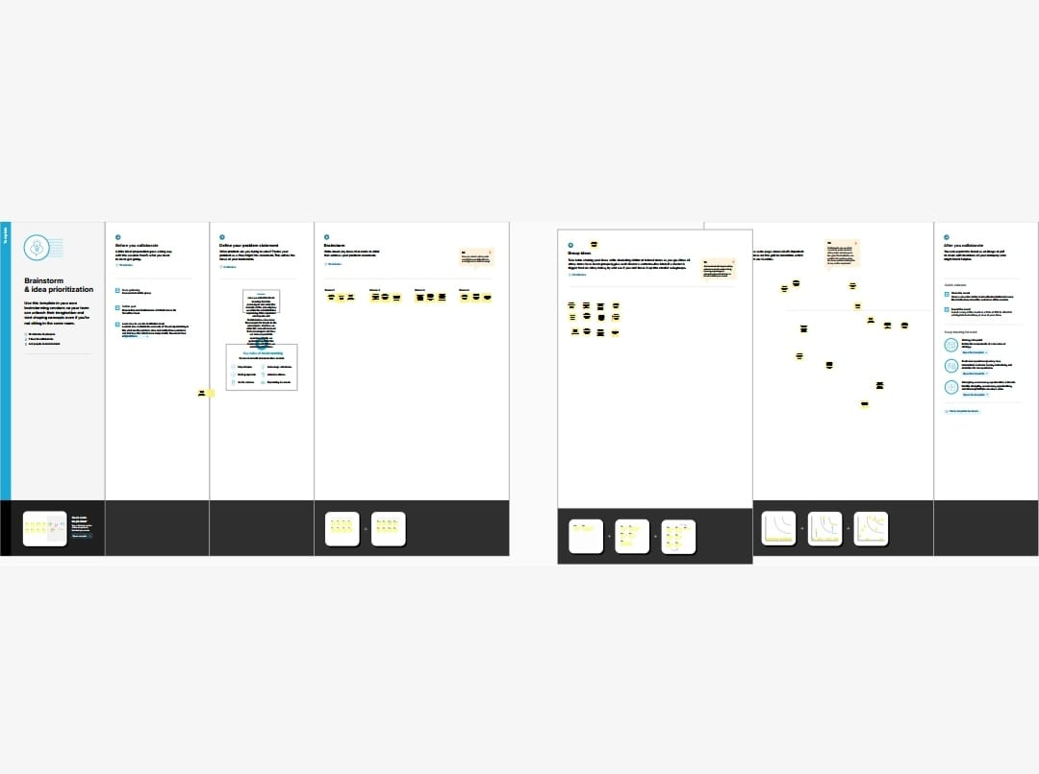

**3. RESULT**;

To Generate the Financial Reports:

1. Profit and Loss Account:

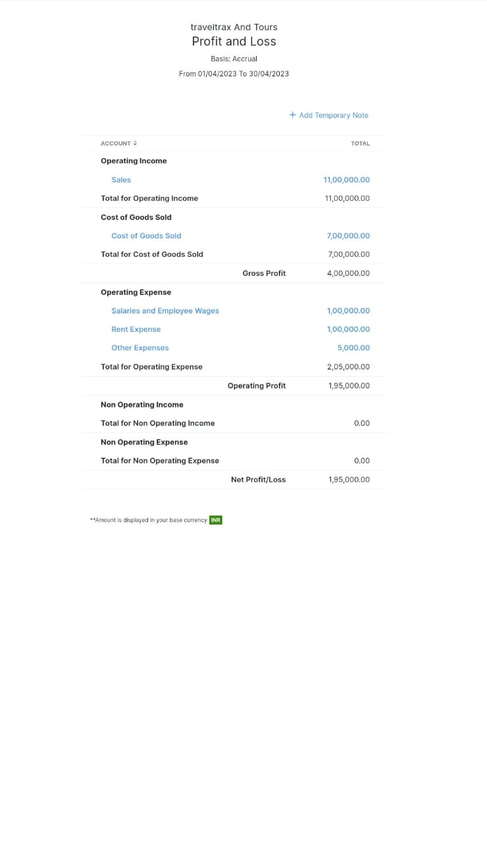

2. Balance Sheet

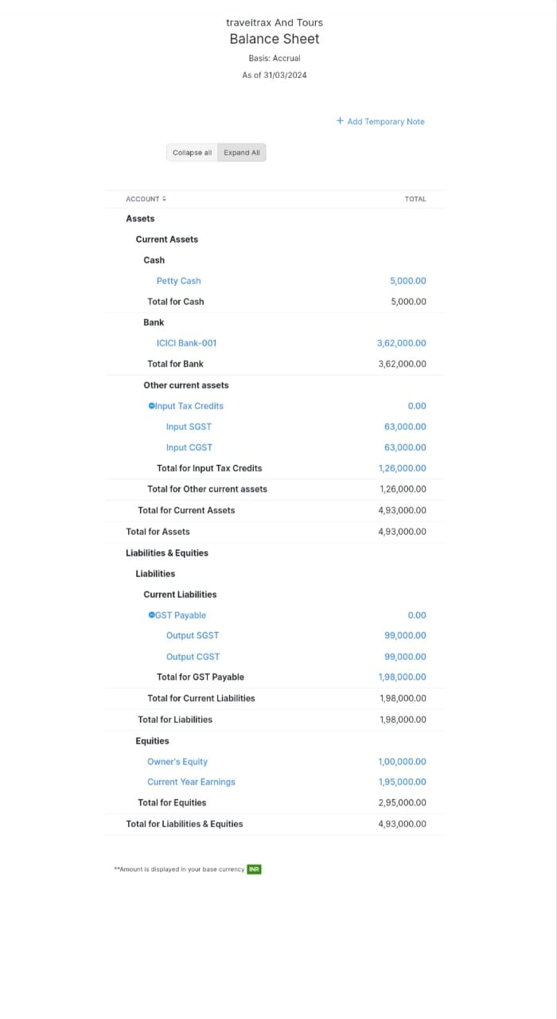

3. GST Reports

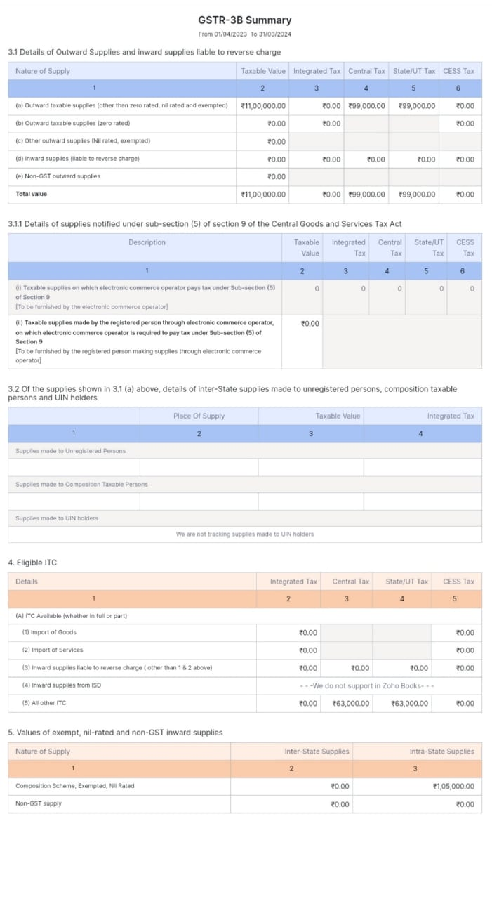



4. Journal Report

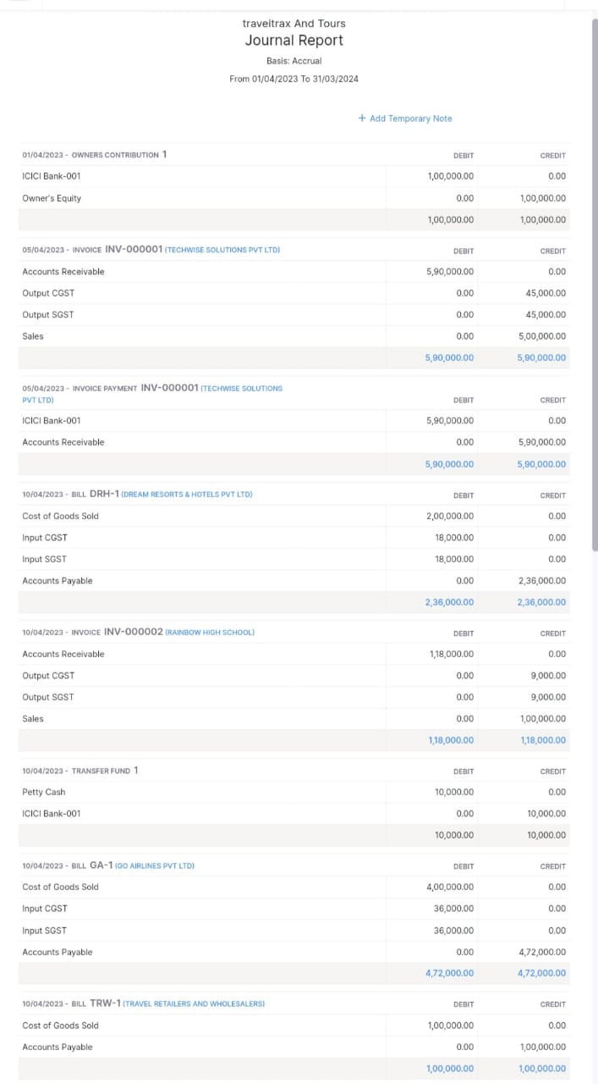

5. Accounts Receivable Summary

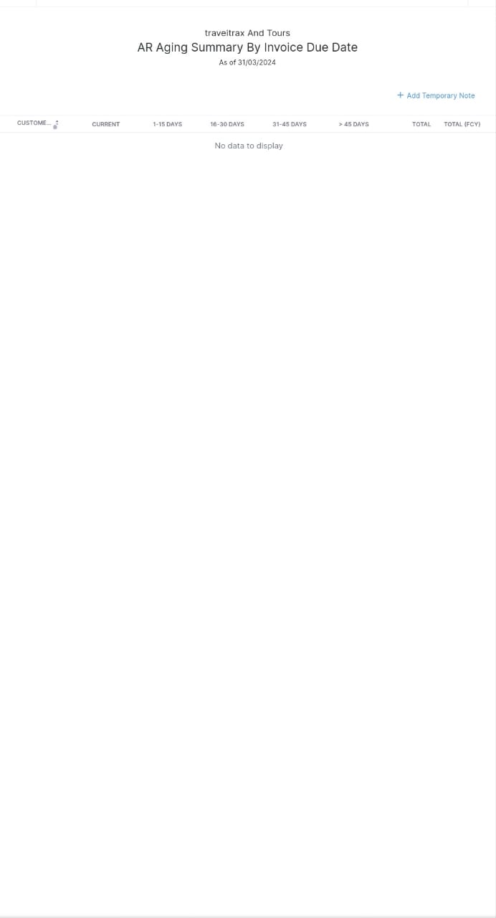

6. Accounts Payable Summary

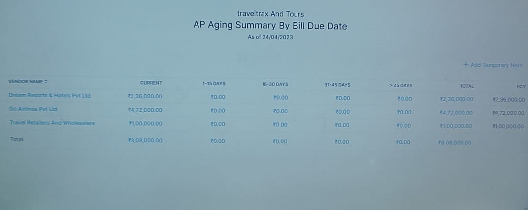

**4. ADVANTAGES & DISADVANTAGES**

List of advantages:

* ZOHO books is cloud based software, so we access the software in any location.
* Creating of Organization is very easy and user friendly.
* Appearance of software model is very easy to understanding.
* Creation of items, vendors, customers are user friendly while compare with software
* Preparation of purchase order and conversation to purchase Invoice made in a single step.
* Preparation of Sales order and conversation to Sale Invoice made in a single step.
* Default accounting step up is very useful and time saving.
* GST procedure is very easy to enter.
* Getting financial report and tax report in single step.

List of disadvantages:

* ZOHO books is cloud based software, which need internet and other technical facility.
* In absence of internet facility, the working in ZOHO books is very difficult.
* There is no secure in data of the organization.

**5. APPLICATIONS:**

The ZOHO Books is good software in all type of organization and we get better results instantly. We collect the following data and entered in ZOHO Books in various modules like item creation, Vendor creation, customer creation, preparation of Purchase order, Purchase Invoice, sales order, sale Invoice, Making payment to vendors and Expenses, Received amount from Customers.

**Item creation:**

Lets Assume TravelTrax Tours is offering below list of various services:

1. Corporate Travel - Rs.5000/- per person

2. Family Travel -Rs.10000/- per person

3. Educational and Learning Tours - Rs.2000/- per person

For the above services to be provided TravelTrax need to purchase the below list of services

1. Transportation Purchases - Cost price Rs.2000/- per person

2. Accommodation Bookings – Cost Price Rs.1000/- per person

3. Tour and Activity utilities – Cost Price Rs.500/- per person

Output GST @ 18% is applicable for all the above services.

**Vendor creation:**

The following are the list of vendors form which various Products and Services are purchased:

1. Go Airlines (GST registered)

2. Dream Resorts & Hotels (GST registered)

3. Travel Retailers and Wholesalers (Non GST)

**Customer creation:**

The below are the list of customers:

1. TechWise Solutions Pvt Ltd (GST Registered).

2. Rainbow High School (GST Registered).

3. Swaminathan & Family (Non GST)

**Preparation of Purchase order, Purchase Invoice:**

1. 05-04-2023 Dream Resorts & Hotels – Accomodation Bookings - For Qty 200 Persons

2. 10-04-2023 Transportation Purchases From GO Airlines- For 200 persons

3. 10-04-2023 Tour and Activity Utilities from Travel Retailers & Wholesalers- Qty 200

**Preparation of sales order, sale Invoice:**

1. 05/04/2023 TechWise Solutions Pvt Ltd – Corporate Travel Booking for Qty 100 Persons - paid through bank on 15/04/2023

2. 10-04-2023 Rainbow High School- Education and Learning Tour for Qty 50 Students

3. 15-04-2023 Swaminathan & Family – 300Hrs for Legal Consulting

**Making payment to vendors and Expenses:**

1. Employee salaries of total Rs.1,00,000/- paid through bank on 30th April 2023.

1. Office Rent Rs.1,00,000/- excluding GST @ 18% Total Invoice Value Rs.1,18,000/- paid through Bank on same day.

2. Other Miscellaneous Expenses Rs.5,000/- paid in cash

3.25-04-2023 Paid to Dream Resorts & Hotels Pvt Ltd Rs. 236000

4. 25-04-2023 Paid to Travel Retailers and Wholesalers Rs. 100000

5. 25-04-2023 Paid To Go Airlines Pvt Ltd Rs. 472000

**Received amount from Customers:**

1.05-04-2023 Amount received from Techwise Solutions Pvt Ltd Rs. 590000

2. 10-04-2023 Amount received from Rainbow High School Rs. 118000

3. 15-04-2023 Amount received from Swaminathan & Family Rs. 590000

**6. CONCLUSION:**

In maintain of Traveltrax Tours accounts in Zoho books is very smart in all the aspects of entries. The basic accounting concept is enough for the operating person (Accountant/Data entry operator). This software is applicable for all types of organization. The entry models of software are easily understood and interest to work. Whatever reports we need, it’s already default in the report models. Totally it’s a good and very useful to the entire entrepreneur with low cost for operating financial department.

**7. FUTURE SCOPE:**

The idea for the founders of ZOHO Books is amazing and very clever. This is a great milestone in the field of accounts maintenance. They offer various plane as per the requirement of the proprietors. It’s a good gift to all the entrepreneurs.